媒体控制

Media Control Service (MCS)

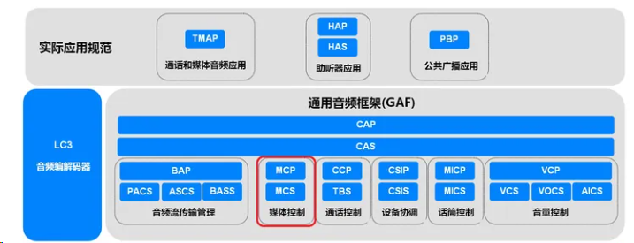

媒体控制[服务器](https://so.csdn.net/so/search?q=%E6%9C%8D%E5%8A%A1%E5%99%A8&spm=1001.2101.3001.7020)是与媒体控制客户端交互以管理媒体轨道并将各种状态和设置传递给媒体控制客户端的设备。媒体控制客户端是发起播放和暂停、确定播放顺序以及从媒体控制服务器收集搜索结果的设备。 媒体控制服务器应为GATT服务器。 媒体控制客户端应为GATT客户端。

### 概述

The Media Control Service (MCS) resides on the source of audio media and reflects the state of the audio stream. The state machine allows a Client using the Media Control Profile (MCP) to transition each media source through Playing, Paused and Seeking states.

1) At its simplest, it allows an earbud to control Play and Stop.

2）higher level functions, search for tracks, modify the playing order, set up groups and adjust the playback speed. It defines metadata structures which can be used to identify the tracks and uses the existing Object Transfer Service (OTS) to allow a Client to perform media searches on the Server, or more typically the application behind it. All of this means that a suitably complex device running the Media Control Profile can recreate the controls of a music player.

媒体控制服务端必须支持一个通用媒体控制服务(Generic Media Control Service, 简称GMCS), 并可同时支持多个媒体控制服务(Media Control Service, 简称MCS). 例如一种音频播放器(例如音乐应用)的功能手机作为媒体控制服务端仅支持一个GMCS，而同时支持多个音频播放器(例如音乐+微信+Webex Meet等应用)的智能手机支持一个GMCS和多个MCS. GMCS和MCS的蓝牙技术规范都是媒体控制服务(Media Control Service).

### Object Transfer Service 1.0

This service provides management and control features supporting bulk data transfers which occur via a separate L2CAP connection oriented channel. The Client is enabled to create and delete objects and to execute an action using the currently selected object. The selected object can be written, updated, or read via an Object Transfer Channel opened by the Client. The generation of a checksum covering a part or the whole of the object contents is included as an optional feature.

This service provides a general method for a Client to select and initiate the transfer of any type of object.

MCP和MCS包括很多功能来支持复杂的用户界面，比如汽车的AV系统的屏幕。其中大部分是基于现有的蓝牙LE对象传输服务（OTS），该服务允许将扩展信息与组和跟踪相关联。这包括扩展的名称、图标和url，它们可以用于获取更复杂的对象，如相册封面。OTS也用于返回搜索结果。

GMCS和MCS可选内嵌(Included)支持对象传输服务(Object Transfer Service, 简称OTS), 可以使用OTS传输媒体播放器图标、曲目信息、曲目列表信息等。

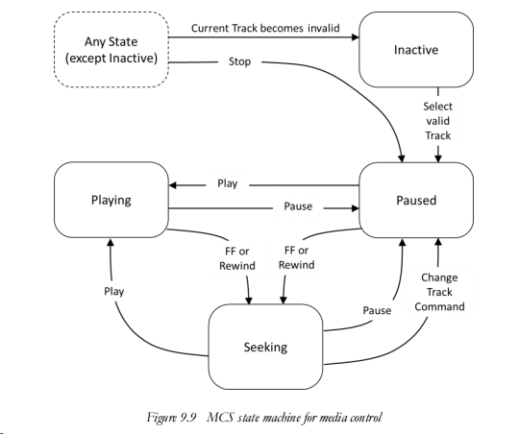

1）normally resides in the Inactive state

2）moving to the Paused State when a Track is selected, from which it can be transitioned to Playing

3）Playing, return to Paused by stopping it, or be moved to the Seeking state by issuing a Fast Forward or Fast Rewind command

### Tracks

Group->专辑，traces->歌

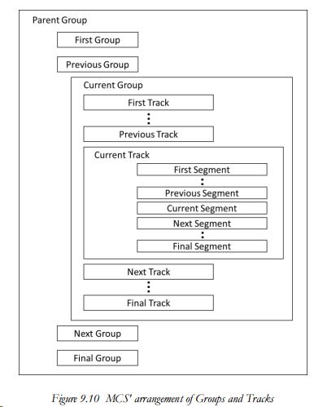

Groups contain tracks, which may also contain segments. Most of the MCP controls operate

on tracks.

The key elements of a Track are shown in Figure 9.11 , which are the Track Duration, Offsets from either end of the Track and the Playing Position

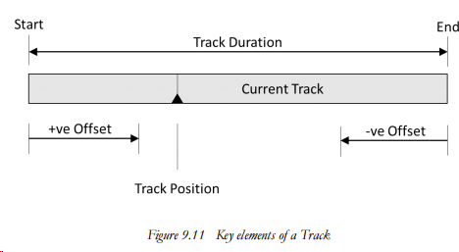

The current track always represents the media for which the player is currently playing, paused, or seeking. If the media player has no current track, then the media player is inactive.

Track Duration是一个期望时间, It cannot be assumed that the track duration is valid; therefore, the track duration should only be considered a guide to the length of the current track. When the current track is being played, usually the media is played at the playback speed, which is an adjustable value that may be faster or slower than the nominal, real-time speed of the track.

为了帮助重新定位，可以公开轨迹段对象，允许发现当前轨迹中的不同段。每个段包括一个名称和从当前轨道开始到段开始的绝对偏移量。因此，此偏移量可以用作移动到段开始的绝对轨迹位置。

### LE Audio中定义的媒体控制特性

MCS provides characteristics that describe the media player and allows the media player to be controlled.

MCS exposes characteristics that describe a single media player.

The description of the media player is comprised of the following:

• Media player information, including media player category, icon, and current rendering targets

• A current track and associated track information

• The next track

• Playback speed

• A current group

• The playing order of tracks within the current group

• The media state of the media player

MCS中定义了下列特性，MCP客户端可以读取MCP服务端上MCS的所有特性的值，可修改部份特性的值；绝大多数特性可以配置为当值改变时MCP服务端主动将更新后的特性值通报(Notify)给MCP客户端。

|  |  |  |
| --- | --- | --- |
|  | Requirement | Value |
| Media Player Name | M | UTF-8 string |
| Media Player Icon Object ID | O | 0/ six octets (the size of uint48) that is in the range of a valid Object ID as defined in OTS |
| Media Player Icon URL | O | UTF-8 string |
| Track Changed | M |  |
| Track Duration/ Track Position | M | the length of the current track in 0.01-second resolution as a  32-bit signed integer  Unknown value shall be 0xFFFFFFFF. Otherwise, the duration of the track shall be zero or greater. |
| Playback Speed | O |  |
| Seeking Speed |  |  |
| Media State |  |  |
| Media Control Point/ Media Control Point Opcodes Supported |  |  |
| Search Control Point/ Search Results Object ID |  |  |

下面具体介绍三种媒体控制特性，以显示LE Audio相较经典蓝牙音频规范AVRCP在媒体控制上的性能提升。

1 Playback Speed

MCS在播放速度特性中定义了一个带符号的8位整数p, 并根据以下公式计算相对正常播放速度倍数的播放速度



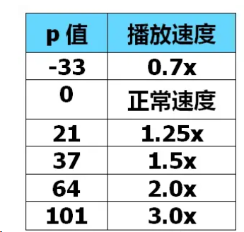

**2 Playing Order**：适应各类媒体自动播放的需求

* 单曲一次/单曲重复/按顺序播放一遍/按顺序重复播放/最后一曲播放一次
* /最后一曲重复播放/第一曲播放一次/第一曲重复播放/随机播放一遍/随机重复播放

**3 Media Control Point**

MCP对MCS中的媒体控制点(Media Control Point)特性进行不同的操作可以实现各种与媒体播放相关的控制功能，包括如下播放控制操作:

* 播放(Play)
* 暂停播放(Pause)
* 快退(Fast Rewind)
* 快进(Fast Forward)
* 停止播放(Stop)
* 移动到当前曲目指定位置(Move Relative)
* 上一曲目(Previous Track)
* 下一曲目(Next Track)
* 第一曲目(First Track)
* 最后曲目(Last Track)

客户端特性描述符(Client Charactristic Configuration Descriptor，CCCD)，这个描述符是给任何支持通知或指示功能的图形额外增加的。该描述符是一个2位的数值，分别用于设置通知与指示，但是不允许同时设置。在CCCD中写入“1”使能通知功能。写入“2”使能指示功能。写入“0”同时禁止通知和指示功能

